Full Steam Ahead: Shay Days Returns July 17-18
Friday and Saturday, July 17-18, 2026 | 10 am to 3 pm
The Harbor Springs Area Historical Society invites the community to celebrate the life and legacy of one of Harbor Springs' most remarkable residents during the 28th annual Shay Days, the Historical Society's longest-running community event. Held Friday and Saturday, July 17-18, this family-friendly festival features live steam and electric model train displays, blacksmithing and wood carving demonstrations, hands-on games and crafts, tours, a birthday party, and more in celebration of inventor Ephraim Shay. Most Shay Days activities are by donation, making the festival one of the area’s most affordable family summer events.
A Celebration of Ingenuity and Community
Shay Days takes place from 10 a.m. to 3 p.m. each day in Shay Park and at both the Harbor Springs History Museum and the Ephraim Shay Works Museum. Throughout the weekend, visitors of all ages can explore the inventive spirit of Ephraim Shay through demonstrations, activities, and interactive experiences.
New this year, local artist and woodworker Dawson Moore will be giving wood carving demonstrations. Through these demonstrations, visitors will learn how timber harvested during Harbor Springs' logging boom was transformed into useful products. On Saturday only, blacksmith Joe LaFata will be in Shay Park with his mobile forge to demonstrate how iron and other metals were shaped during Shay’s era in Harbor Springs.
For a full schedule of events, visit HarborSpringsHistory.org. Some events, such as the walking tour, require advanced registration. Don’t miss this opportunity to help the society honor a man whose inventive genius transformed the logging industry worldwide and helped shape the town we know today.
Honoring a National and Local Visionary
Civil War veteran, lumberman, and inventor Ephraim Shay (1839-1916) patented his revolutionary geared locomotive in 1881, making it possible to haul heavy loads of logs up steep grades and through rough terrain. More than 2,700 Shay locomotives were built and shipped around the world.
Yet Shay’s influence reached far beyond the rails. After settling in Harbor Springs in 1888, he established the city’s first water works system, built a logging railroad, helped to establish the local Little Traverse Yacht Club, built his unique hexagon house and was active in community organizations such as the Grand Army of the Republic.
Tour the Ephraim Shay Works Museum
Opened just a year ago during Shay Days 2025, the Ephraim Shay Works Museum inside Shay’s iconic stamped-steel Hexagon House features hands-on and interactive exhibits for visitors of all ages. Each wing of the unique hexagon house explores a different chapter of Shay's life, from his locomotive invention and Civil War service to the engineering innovations that shaped both industry and Harbor Springs.
“Our goal with the Ephraim Shay Works Museum was to create a space that’s both educational and inspiring,” says Beth Wemigwase, Curator and Program Coordinator of the Historical Society. “We’ve designed interactive stations that emphasize creativity, problem solving, and hands-on discovery. Whether you're fascinated by trains, engineering, local history, or simply looking for a fun family outing, there's something here for everyone.”
Visitors who attend Shay Days will get 50% off admission to the new museum: $10 for adults, $7.50 for seniors, $5 for students (K-College) and free for children under the age of 5. Admission to all other activities will be by donation, with all proceeds supporting the Historical Society.
Plan Your Visit
Bring the whole family and discover why Shay Days has become one of Harbor Springs' favorite summer traditions. Explore trains, history, invention, hands-on activities, and the newly opened Ephraim Shay Works Museum—all while celebrating the remarkable inventor who helped put Harbor Springs on the map. For more information, please call (231) 526-9771 or visit www.HarborSpringsHistory.org.
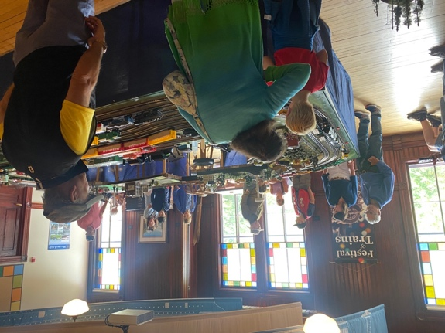
CAPTION: The Northern Michigan Railroad Club of Traverse City will be at the Harbor Springs History Museum both July 17 & 18 with some of their electric model train layouts! Stop by to ask them about their junior engineer’s program and explore their train layouts.

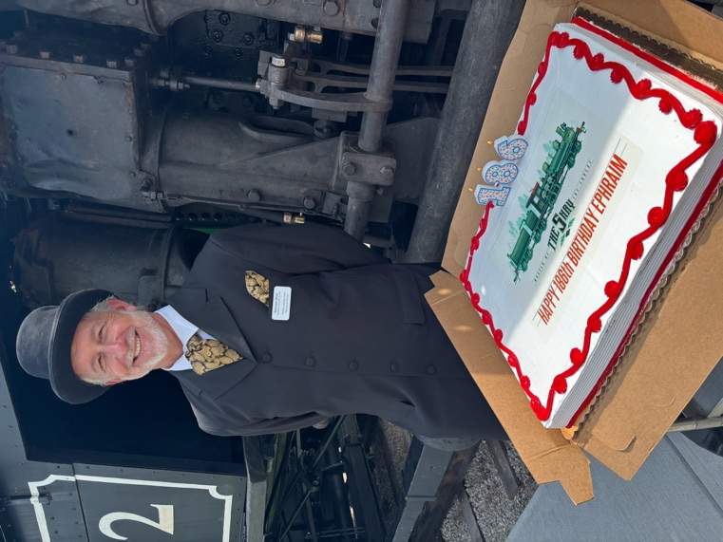
CAPTION: Actor Jim Russell will be in Shay Park both Friday and Saturday portraying Ephraim Shay. Guests can chat with Mr. Shay and climb into the cab of the Shay Locomotive he invented for a photography opportunity. At 1:30 pm on Saturday, the society holds a birthday celebration for Mr. Shay (who would be turning 187!) including cake for all attendees.

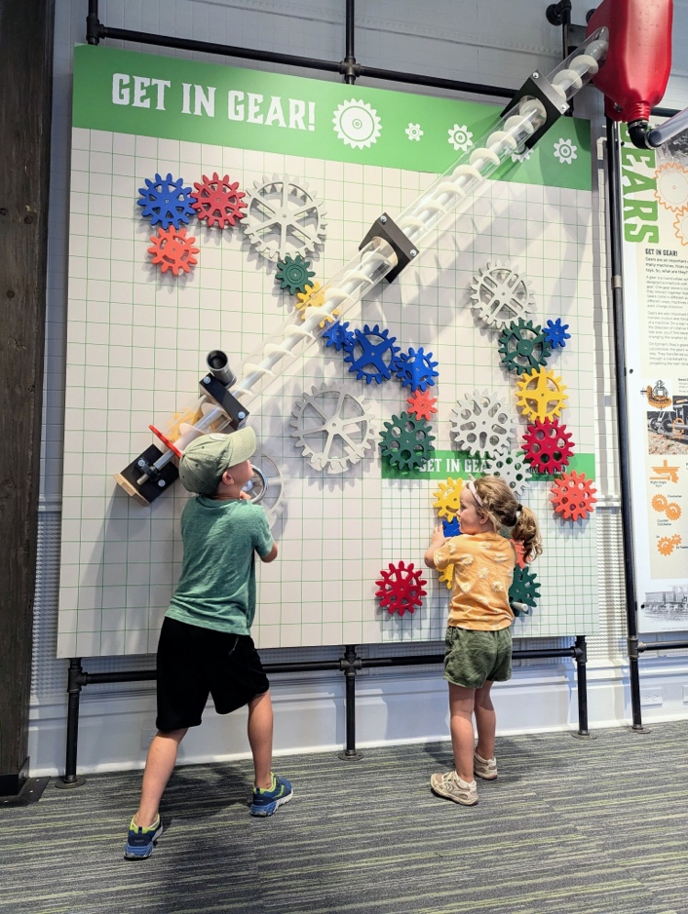
CAPTION: Explore the new Ephraim Shay Works Museum both Friday & Saturday. Photograph courtesy of Mark Tarquini.



